桃園市桃園區建德國小110學年度第一學期六年級英文領域 期末定期評量試卷

六年____班 座號：_____ 姓名：__________ 分數：__________

1. Listen and Choose (14%)

仔細聽對話，寫出正確的答案。

**Part A** 選擇題 Choose the Answer

( ) 1. Where is Judy from?

1. She is from Japan.
2. She is from Greece.
3. She is from Italy.

( ) 2. Are Judy’s father and mother from

Italy?

1. No, her father is from Italy,  
   but her mother is from Greece.
2. No, her father is from Greece, but her mother is from Italy.
3. No, her father and mother are from Greece.

( ) 3.Where is Ted’s father from?

1. She is from Japan.
2. He is from Italy.
3. He is from Japan.

**Part B** 是非題Mark O or X

( ) 1. Dr.K has a blue T-shirt.

( ) 2. Peter takes a new water bottle in

his hand.

( ) 3. Lily has a cellphone in her pocket.

( ) 4. The four people in the photo all

wear gloves.

1. Listen and Number (15%)

仔細聽，寫出發音字的數字順序。

1. ( 　) skin ( 　) spin ( 　) sting
2. ( ) ring ( 　) king ( 　) ting
3. ( ) drink ( 　) wink ( 　) mink
4. ( 　) spring ( 　) swing ( 　) skiing
5. ( 　) spend ( 　) skunk ( 　) stank
6. Look and Write (12%)

看圖片，拼寫出單字。

**習作P32-2習作P33-1**1. 2.

_______________________ _______________________

**習作P36-1習作P37-1**3. 4.

_______________________ _______________________

四、Fill in the Blank (12%) <注意大小寫>

(一)依主詞填入正確的Be動詞

1. ___________ you a student?

2. Ken and Andy ___________ good friends.

3. This ___________ a book.

4. Dad and I ___________ eating lunch.

5. ___________ the eraser red?

6. Allen, ___________ your sisters tall?

(二)依括弧中的主詞填入正確的所有格

1. _______________ pencils are colorful. (Louis)

2. They are _____________ trees. (they)

3. You are the apple of ___________ eye. (I)

4. ___________ dogs’ toys are cute. (he)

5. We love ___________ school. (we)

6. Is this __________________________________ cat?

(Elsa and Anna)

五、Read and Choose (12%)

仔細讀，選出正確的答案

( ) 1. Lily is from _____________.

1. Thursday
2. Taiwan
3. T-shirt

( ) 2. Today is very cold. I want ________.

1. swimsuits
2. shorts
3. gloves

( ) 3. Q: Annie, are they __________ keys?

A: Yes, they are __________ keys.

(a) you ; I

(b) your ; my

(c) your ; your

( ) 4. Q: Are you from Taiwan?  
 A: No, we aren’t. I am from _______

and Ellen is from _______.

1. the UK ; the USA
2. Taiwan ; the USA
3. the UK ; Taiwan

( ) 5. Q: They are scary.

A: Don’t worry. ____________________

1. I could eat a horse.
2. It’s all Greek to me.
3. You’re under my umbrella.

( ) 6. (a) They are Grandma glasses.

**課本P61-3** (b) They are Grandma’s glasses.

(c) They are Grandma’s glass.

六、Read and Choose (30%)

仔細看，寫出正確的答案

|  |  |  |  |
| --- | --- | --- | --- |
| **習作P33-2**  Emily | **習作P32-3**  Leo and Ann | **習作P32-1**  Gary | **習作P32-5**  Tina |
|  |  |  |  |

1. 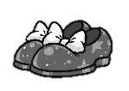____________ is from Japan.
2. ____________ ____________ they ?

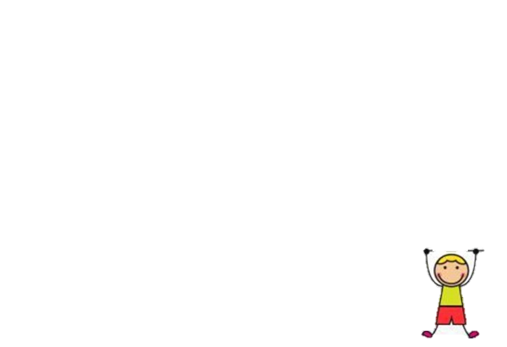They ________________________________________

1. ____________ is from?

____________ is from ____________.

1. ____________ ____________ it ?

It ___________________________________________

1. Leo and Ann ____________ from ____________.

They have three _________________________.

七、Read and Draw (5%)

根據提示，畫出人物擁有的物品及數量。

|  |
| --- |
| 1. Sandy has four shoes and one glove.  2. There are nine keys in Eddie’s bag.  3. Tom has two glasses and five watches. |
|  |