桃園市建德國小105學年度第2學期五年級英文領域 期中定期評量試卷
五年____班 座號：_____ 姓名：____________ 分數：__________

- Listen and choose (10%) 聽並選出單字代號
  - ( ) a. spar b. star
  - ( ) a. speed b. steed
  - ( ) a. Candy b. Cindy
  - ( ) a. cent b. cut
  - ( ) a. cell b. call

- Listen and check (10%) 聽並勾選正確的圖片

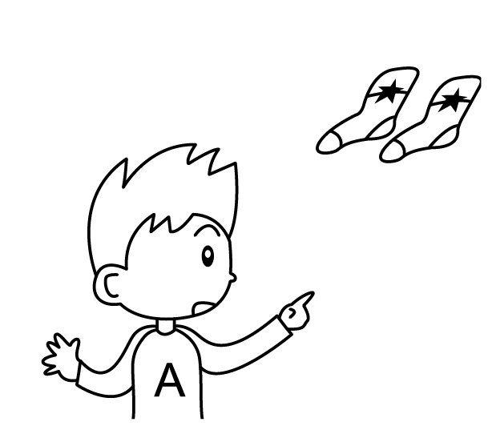
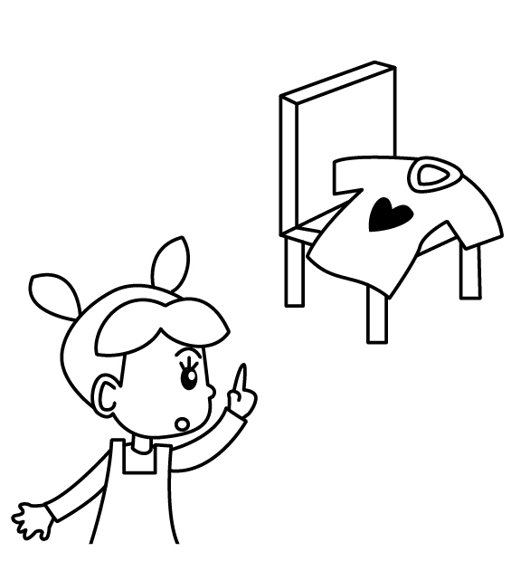
1.

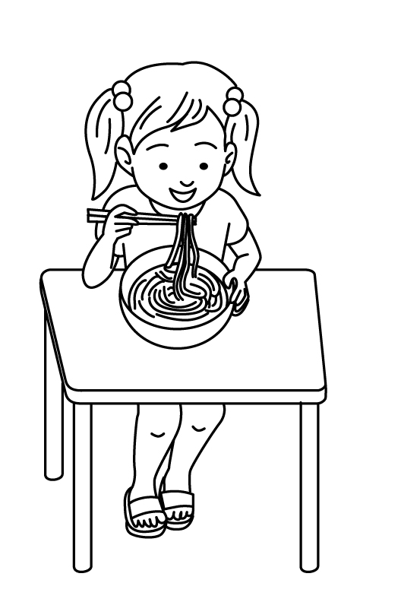
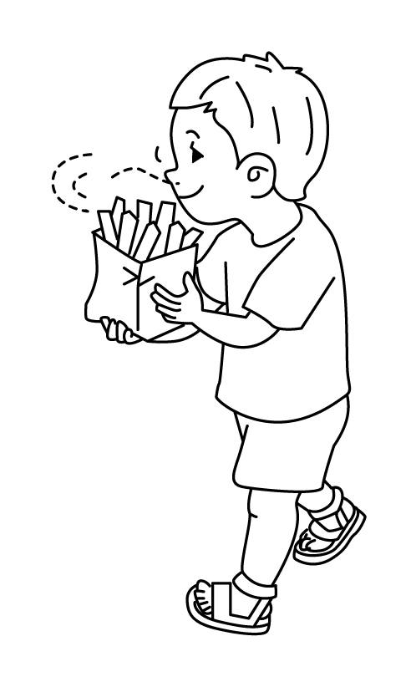
2.

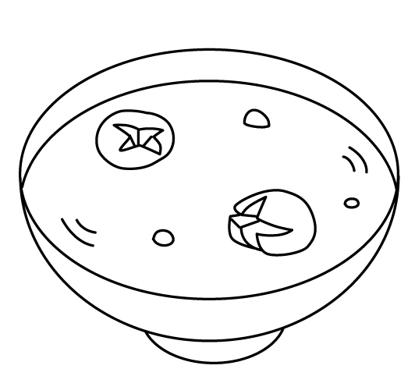
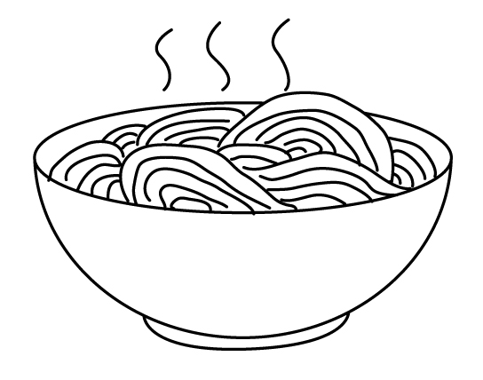
3.

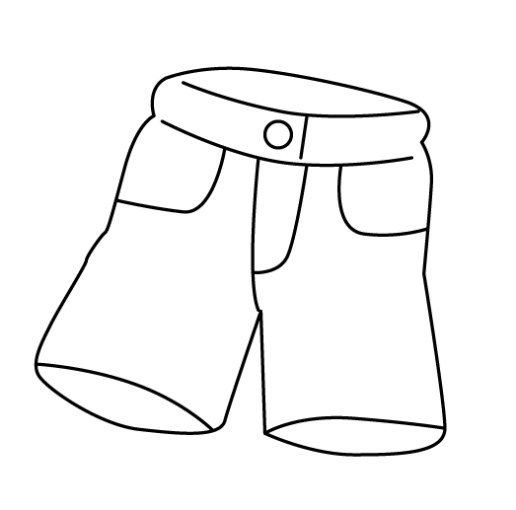
4.

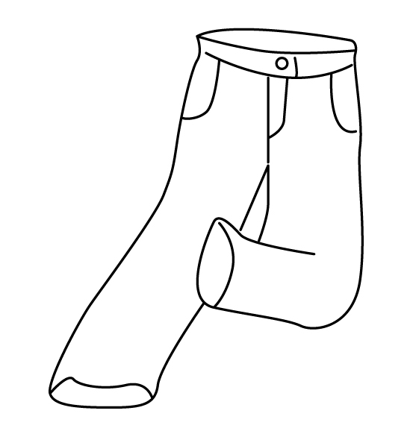

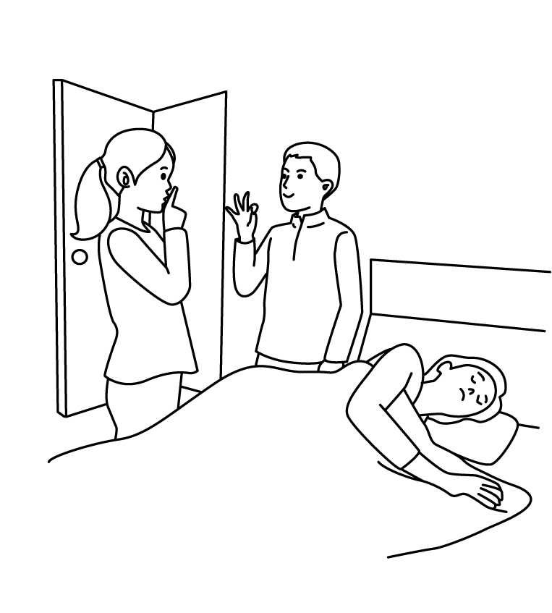
5.

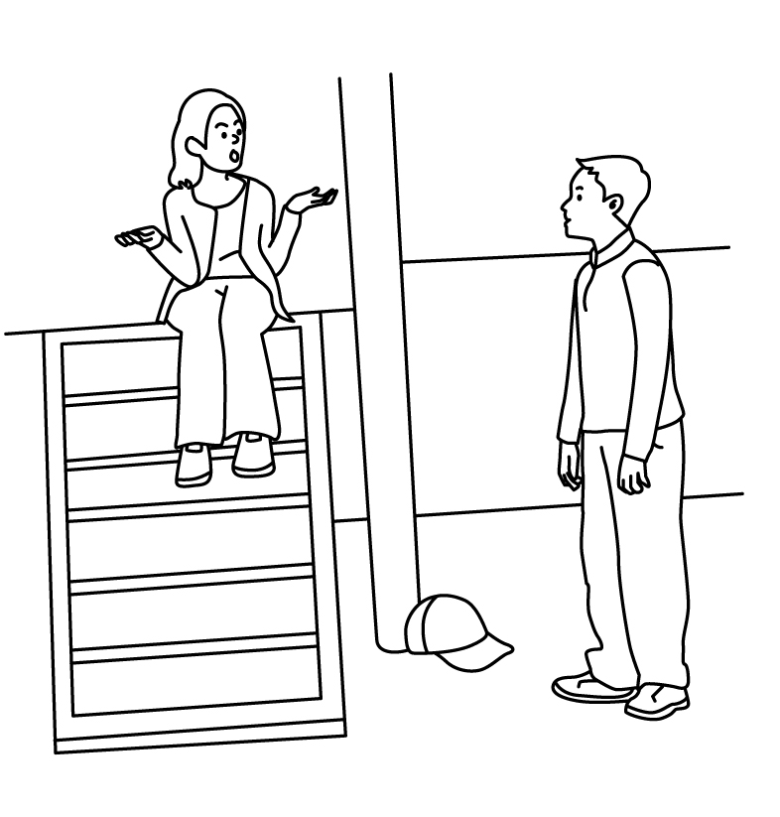

- Listen and match(12%)聽並將圖片連到對的人名

Sally Ricky Linda John
● ● ● ●

● ● ● ●
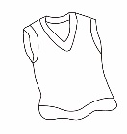
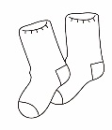
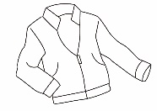
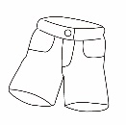

- Listen and choose (10%)聽並選出正確的回應句
( ) 1. (A) No, it’s not Jack’s cap.
(B) It’s David’s cap.
(C) Yes, it’s my sister’s cap.
( ) 2. (A) Let’s take a rest.
(B) Let’s go to school.
(C) Let’s find out.
( ) 3. (A) It’s Amy’s shorts.
(B) They’re Tina’s socks.
(C) I don’t know. They’re not my shoes.
( ) 4. (A) Sorry, I’m late.
(B) Good idea!
(C) Let’s try some.
( ) 5. (A) I don’t like them, either.
(B) I like it, too.
(C) Yuck!
- Look and write依據圖片，回答問題(30%)
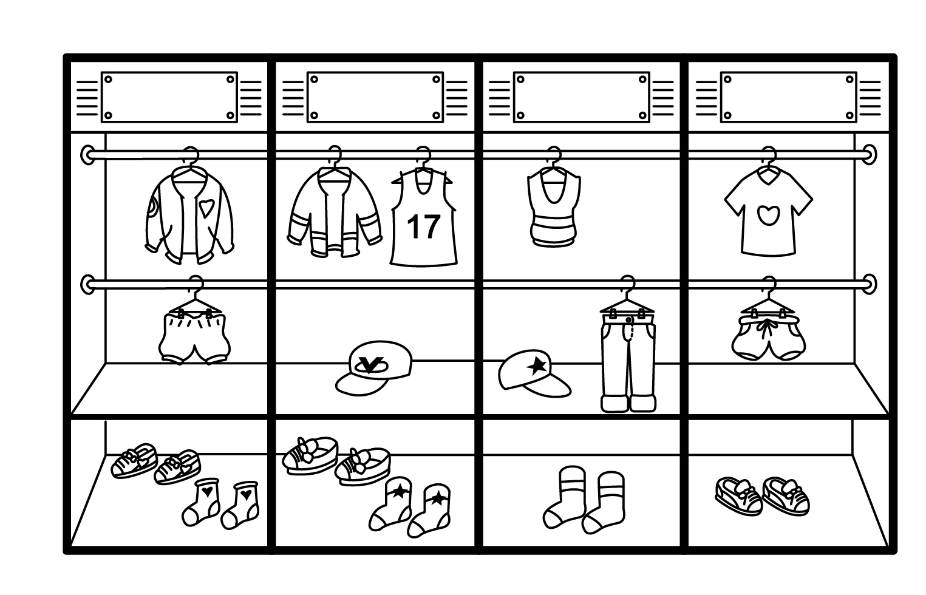
(一)
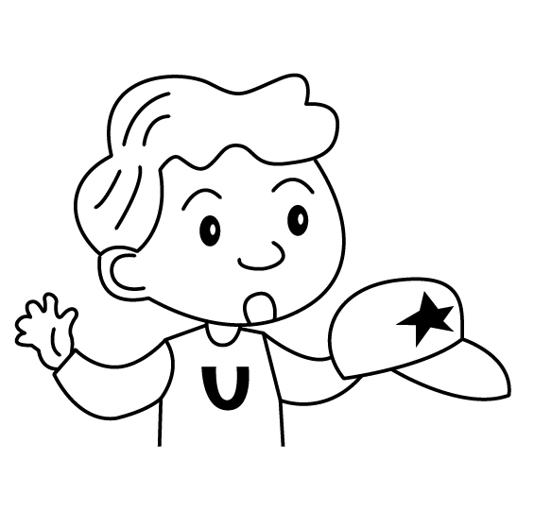  1. | Whose is this?  It’s .
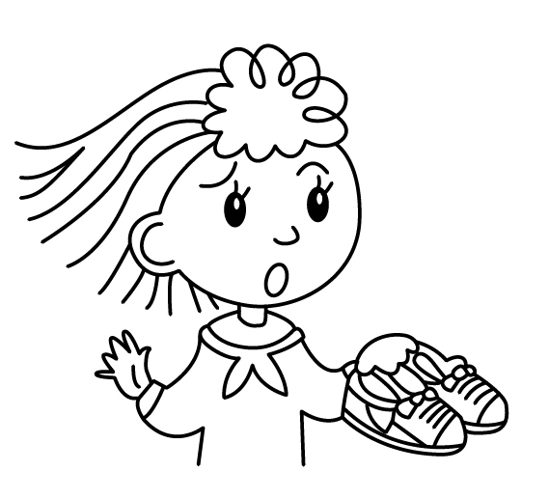  2. | Whose are ?  They Annie’s .
3. | Whose are ?  They are socks.

(二)

 | 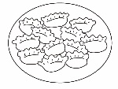 | 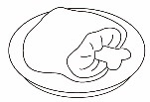 | 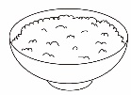 | 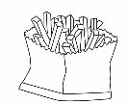
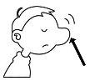 | O | X | X | O
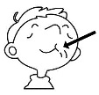 | O | X | O | X
- Do the dumplings smell good?
, they .
- Does the pork taste good?
No, .
- Do the French fries taste good?
No, they taste .

- Read and choose. (8%)仔細讀，選出正確的答案

It is Sunday morning. Mandy and her grandpa are at home. They smell something good. Her sister, Emily, is wearing a dress and eating noodles. Her brother , Simon, is eating dumplings for breakfast. Mandy says,”The noodles smell good.” Emily says,”But they taste bad.”
Annie
Benny
Danny
Emily

( ) 1. Q: What day is today?
A:__________________
(a) It’s Sunday.
(b) It’s Saturday.
(c) It’s Monday.
( ) 2. Q: Where is Mandy’s grandpa?
A: _________________
(a) He is at the park.
(b) He is at school.
(c) He is at home.
( ) 3. Q: What is Simon eating?
A: _________________
(a) He is eating noodles.
(b) She is eating dumplings.
(c) He is eating dumplings.
( ) 4. Q: Do the noodles taste good?
A: ________________
(a) Yes, it tastes good.
(b) No, it tastes bad.
(c) No, they taste bad.

七、Unscramble 重組句子(20%)
  - taste∕good∕the∕Does∕rice
?
  - pants∕.∕They’re∕Peter’s∕not

