桃園市桃園區建德國小105學年度第1學期四年級英語領域期中定期評量試卷
四年 ___班 座號：___ 姓名：__________ 分數：__________

- Listen and Check 仔細聽，將聽到的發音字打勾(12％)
- ( ) cap  ( ) cab | 2. ( )gold  ( )cold | 3. ( ) tin ( ) din
4. ( ) gut  ( ) cut | 5.( ) bet ( ) pet | 6. ( )mad  ( ) mat
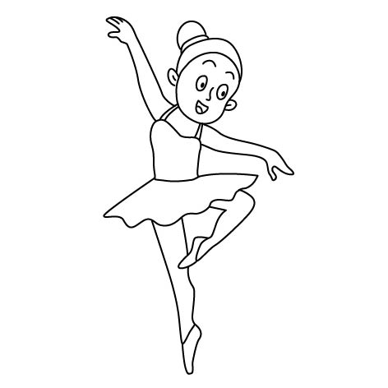
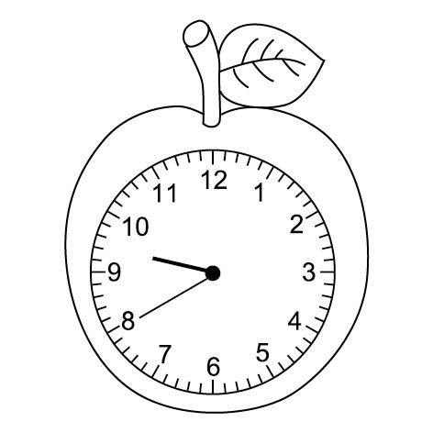
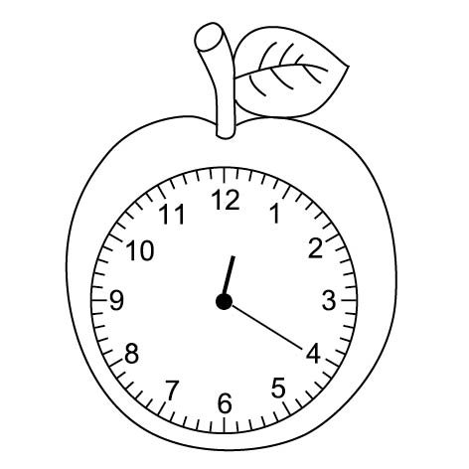
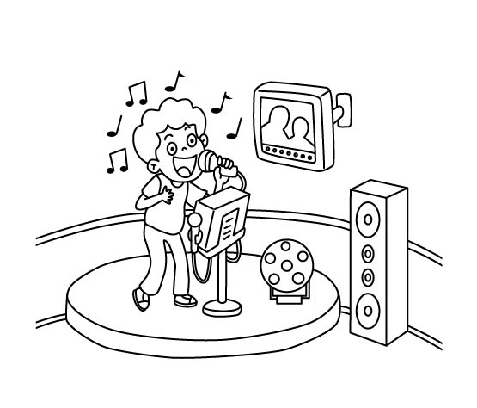
- Listen and Check 仔細聽，勾選正確的單字圖片(12％)
1. 2.
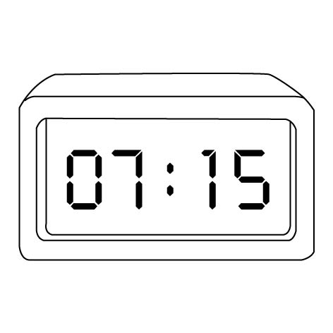
( ) ( ) ( ) ( )
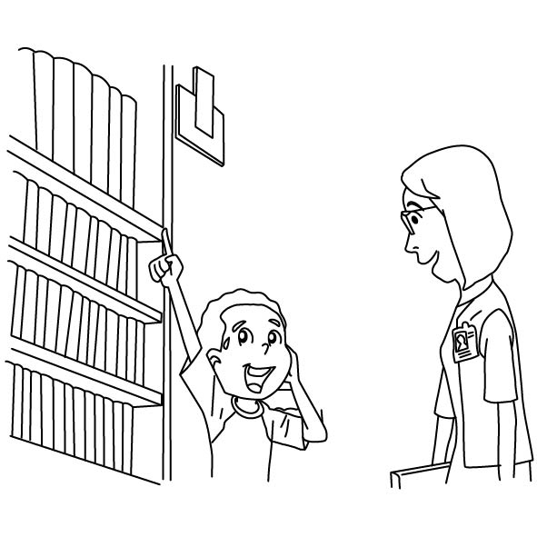
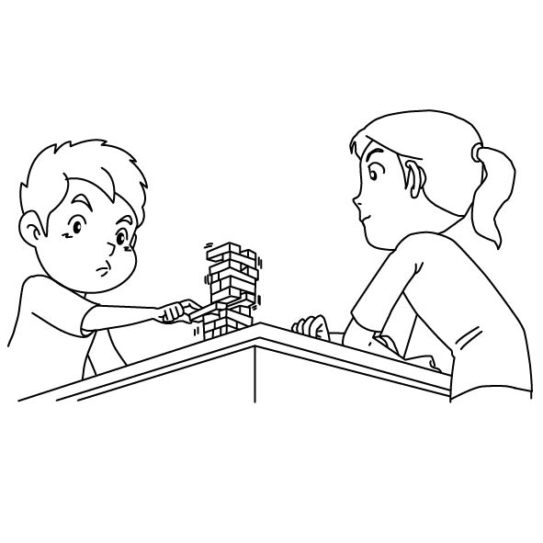
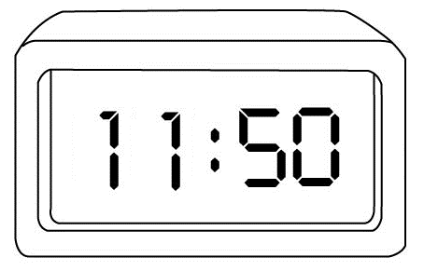
3. 4.
( ) ( ) ( ) ( )
- Listen and Write 仔細聽，將聽到的時間用阿拉伯數字寫下來 (8％)
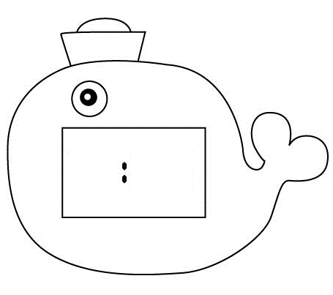
- 2.

3. 4.

- Listen, Number, and Copy 仔細聽，按照聽到的順序先將圖片標上號碼，再寫出正確的單字(20％)
ride a bike thirty swim
forty twenty-five
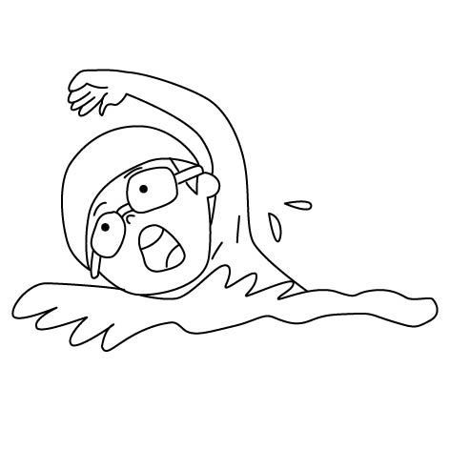
( ) ( )
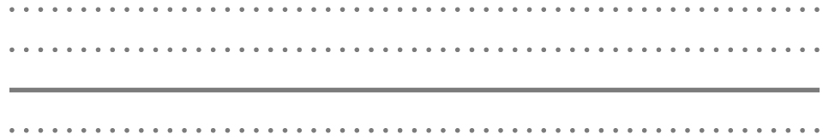
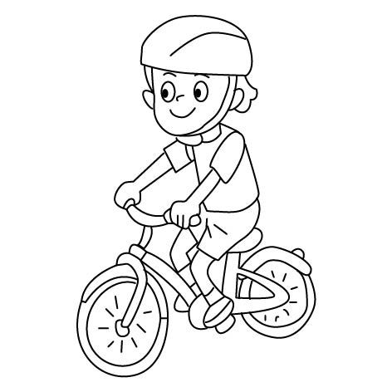
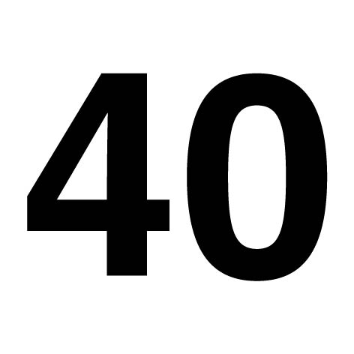
( ) ( )
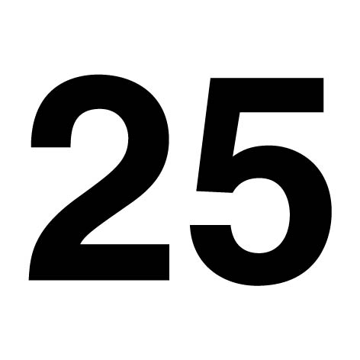
( )
- Look and Choose 看圖選出正確的句子 (18％)
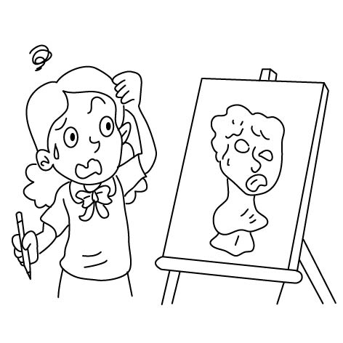  1. ( ) | A: Can you draw?  B: ＿＿＿＿＿＿  (A) Yes, I can.  (B) No, I can’t.  (C) No, I am not.
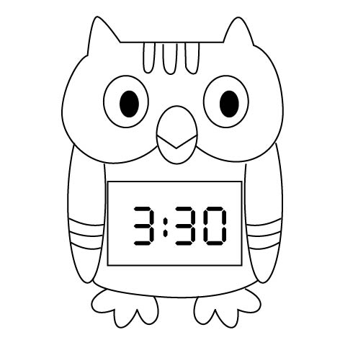  2. ( ) | A: What time is it?  B: It’s ＿＿＿＿＿＿.  (A) three thirteen  (B) three twenty  (C) three thirty
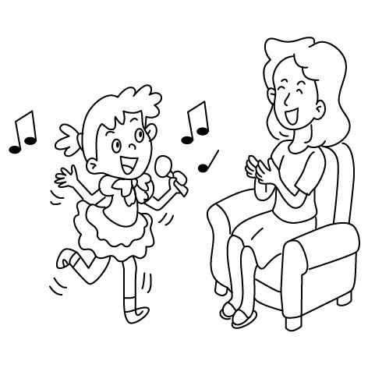  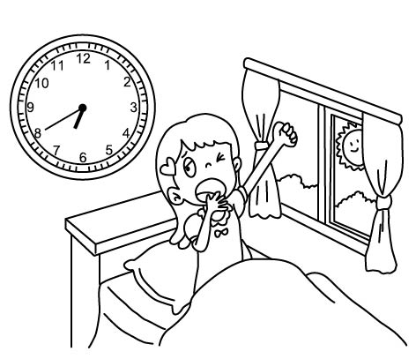  3. ( ) | (A) I can sing and dance.  (B) I can sing and draw.  (C) I can swim and draw.
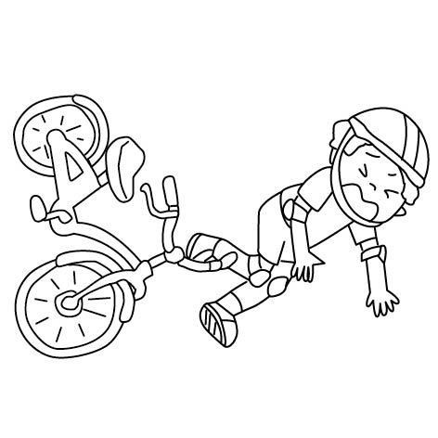  4. ( ) | A: ＿＿＿＿＿＿  B: It’s six forty.  - What time is it ?  - What is this ?  - What color is it ?
5. ( ) | A: Can you＿＿＿＿ ?  B: No, I can’t.  (A) sing  (B) ride a bike  (C) dance
6. ( ) | (A) It’s six fifty.  (B) It’s ten thirty.  (C) It’s five fifty.
- Read and Check 讀一讀，勾選與句子相符的圖片(10％)
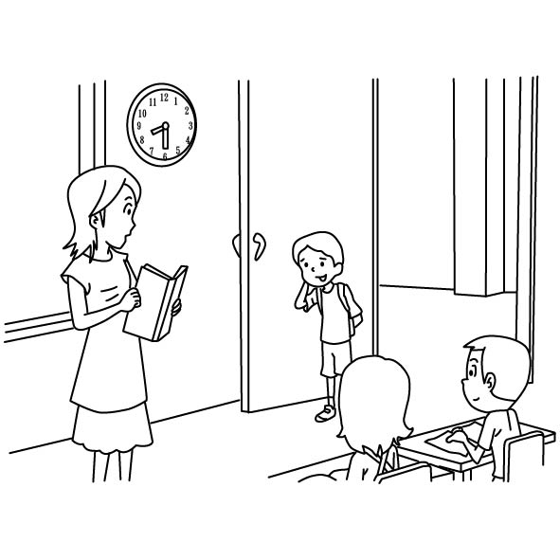
- Sorry, I’m late.

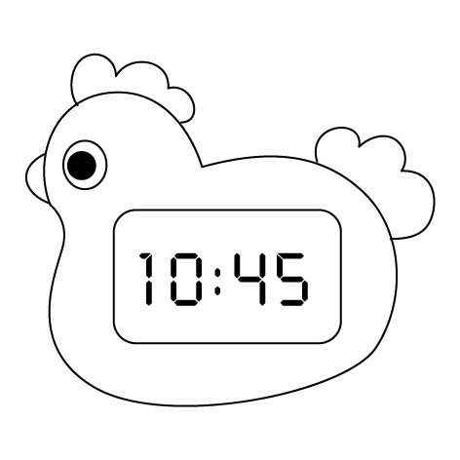
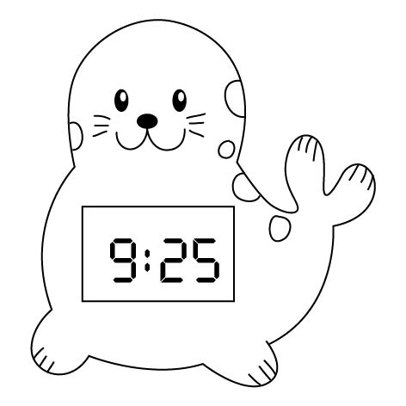
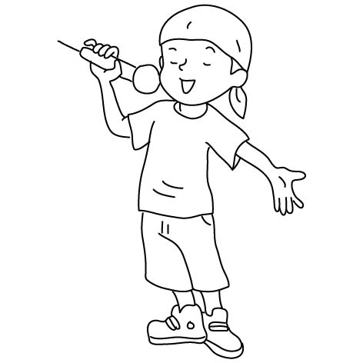
- It’s ten forty-five.

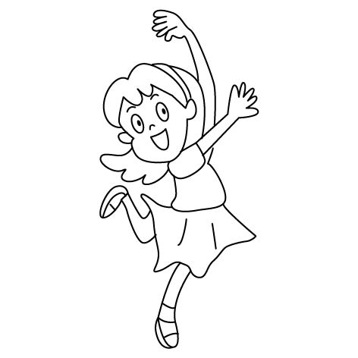
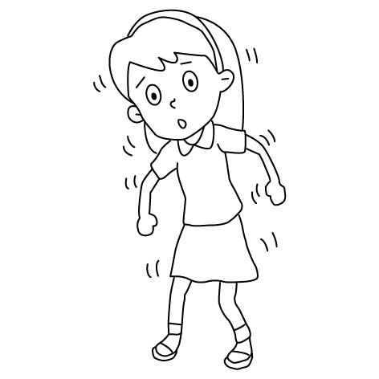
- Can you dance ? Yes, I can.

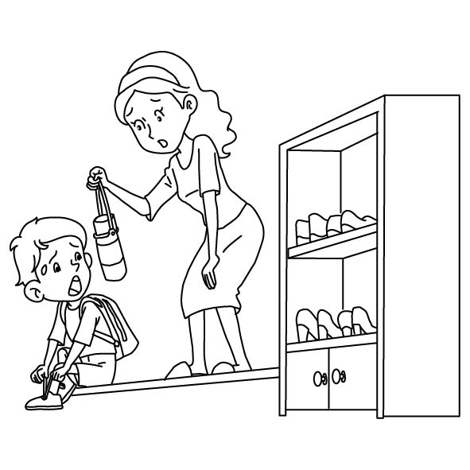
4. Hurry up.

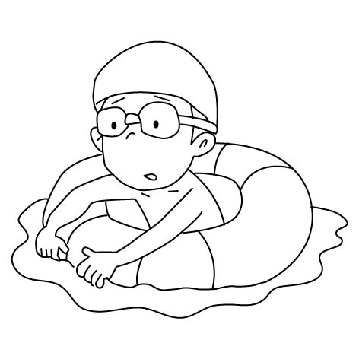
5. Can you swim ? No, I can’t.

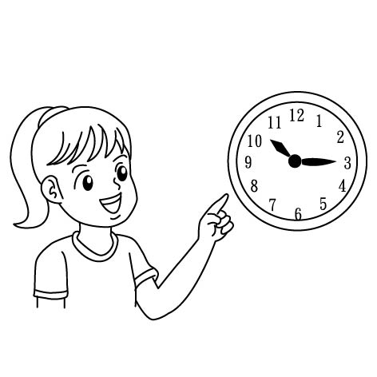
- Look,Read and Copy請依據圖示寫出正確的答案( 20％ )
can can’t four twenty o’clock
swim Yes ten eight time
What is it ?
It’s fifteen.
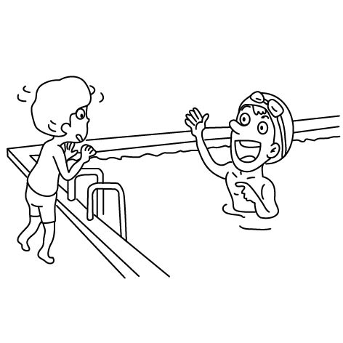  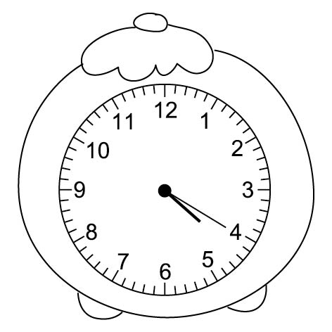 | Can you ?  No, I .
What time is it ?
It’s .
Can you sing ?
, I .
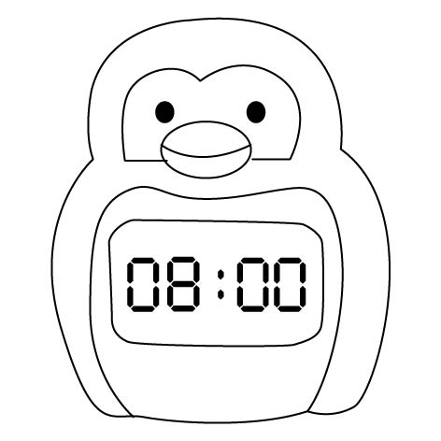 | What time is it ?  It’s .

