桃園市桃園區建德國小111學年度第一學期五年級英語領域期末定期評量試卷
班級：______ 中文姓名：___________ 座號：______ 家長簽章：______
- Listen and Number仔細聽，將發音字依照聽到的順序編號(1~3) 。
(每答1分，共15分)

- ( )card ( )city ( )cent
- ( )Sandy ( )Cindy ( )candy
- ( ) gage ( )page ( )cage
- ( ) come ( ) can ( ) cook
- ( )gum ( ) gym ( )game

- Listen, Circle, and Write仔細聽並圈出正確的單字圖，再將單字寫在格線上(每答2分，共16分)
1. 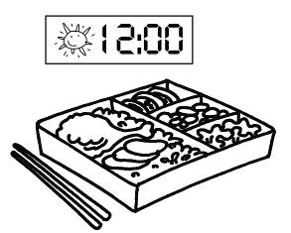 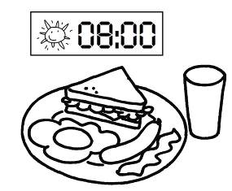
2. 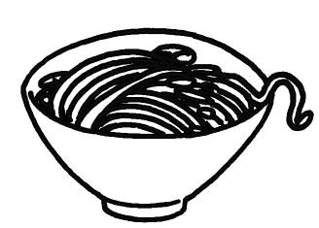 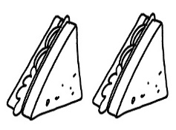

3.  

4.  

- Listen and Mark (O or X)，仔細聽，句子與圖片相符請打O，不符請
打X。(每題3分，共12分)
1.( )   | 2.( ) 
3.( )  | 4.( ) 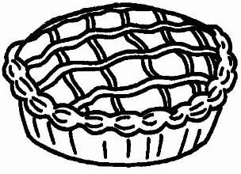
- Read and Choose仔細讀句子，選出最適當的答句或回應句。
(每題3分，共12分)
( )1.Are you hungry?
(A) Yes, I do.
(B) Yes, I am.
(C) Yes, you are.
( )2.What would you like for dinner?
(A) Yes,please.
(B) I would like some soup.
(C) No, thank you. I would like
some soup.
( )3.Would you like some bread for breakfast?
(A) Yes, please.
(B) Yes, I am. I am thirsty.
(C) No, thank you. I would like
some bread.
( )4.How do you feel?
(A) Yes, I am
(B) I feel happy.
(C) Yes, I do.

- Read and Write請依前後文完成
句子。(每題3分，共15分)
Ben: Mom, I’m home.
Mom: How _________________ you feel today?
Ben: I feel _________________. I can swim now.
Mom: Great! Are you _________________? Try
the sandwiches.
Ben: No,I am not. I’m thirsty. I would
like some_________________. Where’s dad?
Mom: He’s sleeping in the bedroom.
He’s _________________.
- Read and Answer看圖回答問題
(每題4分，共12分)

  1.   | A: Would you like some apple  pie?  B:  _______________________________________  _______________________________________
  2. | A: What would you like for lunch?  B:  _______________________________________  _______________________________________
  3. | A: Are you sad?  B:  _______________________________________  _______________________________________

- Read and Check 請閱讀文章並
勾選對(True)或錯(False) 。
(每題3分，共18分)
Peter: Are you angry, Lily?
Lily: No, I’m not. I’m sad.
Peter: Why?
Lily: My cat, Lucky, is sick.
She’s in the animal hospital now.
Peter: I’m sorry to hear that. I’m sad.
Lily: It’s OK. Are you going to the
library?
Peter: No, I’m not. I am hungry.
Lily: It’s eight o’clock.It’s time for
breakfast. What would you like for breakfast?
Peter: I would like some sandwiches. How about you?
Lily: I would like some milk, but I would like some noodles for lunch.
Peter: I would like some soup for lunch.
Let’s go!
 | True | False
1.Lily is angry.
2.Lily’s dog is in the animal hospital.
3.Peter is going to the library.
4. Peter would like some sandwiches for breakfast.
5.Lily would like some noodles for breakfast.
6.Peter is happy.
【 作答到此結束 】
組距表(此表格考試時不必填寫)
100 | 90-99 | 80-89 | 70-79 | 60-69 | 60以下 | 平均

