桃園市桃園區建德國小110學年度第二學期六年級英語領域 期中定期評量試卷
命題範圍：康軒Follow Me Unit 1&2、Review 1
Grade 6 Class____ Number: _____ Name:_________Score: 家長簽名：
A. Listen and Mark仔細聽，選出聽到的字 (5%)  1. ( ) ① bay ② boy ③ bow  2. ( ) ① owl ② eel ③ oil  3. ( ) ① house ② horse ③ how  4. ( ) ① loud ② loan ③ lean  5. ( ) ① clean ② clown ③ cloud  B. Listen and Number仔細聽，寫代號A、B、C (9%)  1.  2.  3.  C. Listen and Number 仔細聽，選適當的答案(8%)  1.( ) ①I’m watching TV.  ②I watch basketball games on TV.  ③I can play basketball.  2.( ) ①No, I don’t. I go fishing.  ②I go fishing.  ③Yes, I do.  3.( ) ①$ 7009  ②$ 7900  ③$ 7090  4.( ) ①He has ants in his pants.  ②The game is in the bag!  ③It’s all Greek to me.  G. Read and Match 根據主詞填入所有格 (10％)  1. Your sister cooks in ____________ free time.  2. I go rock climbing in ____________ free time.  3. My brother meets friends in ____________ free time.  4. Jane and Nina play chess in ____________ free  time.  5. Bob and I like to sleep in ____________ free time.  H. Read anMatch 根據文章，對畫O、錯打Ｘ (10%)  1. ( ) Lily wants to buy gloves.  2. ( ) The tent is six hundred and fifty-four  dollars.  3. ( ) Lily likes to go hiking.  4. ( ) Tina doesn’t go camping.  5. ( ) Lily and Tina can go camping together.  I. Answer questions回答問題(5%)  1. Does your mother go surfing in her free time?  No, _______________________________________.  2. What do you do in your free time?  _______________________________________________________. | D. Listen and Fill In 先讀題目，聽Elsa和Peter的  對話作答 (12%)  1. Elsa and Peter go ___________________________.  2. Peter wants to buy two pairs of  ________________________.  Elsa wants to buy a _________________________.  3. The blue sweater is ________________________  _______________________ and ____________________  dollars.  E. Read and Spell拼出正確的字 (每答3分，共18分)  F. Read and Choose選出錯誤的代號(10%)  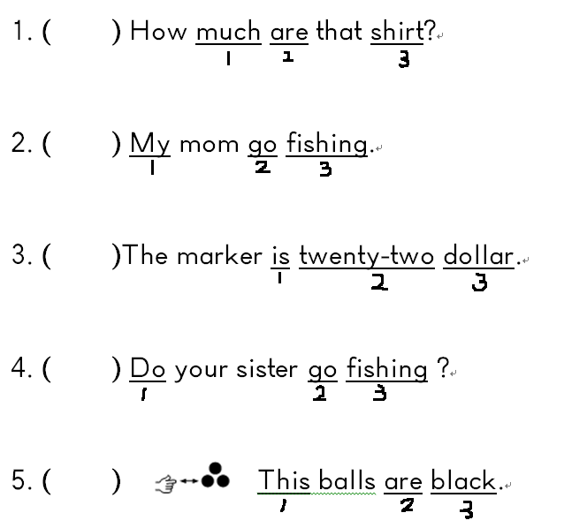  J. Read and Fill In參考提示，填入答案(9%)  $850  $300  $500  1. Billy _____________ ___________________ .  Amy _____________ ___________________ .  What does Danny __________?  He _____________ ______________________.  2. Those ______________ and that _________________ are  one thousand three hundred and fifty dollars.  K. Read and Draw 讀短文，將衣物及價格畫在格子中，注意遠近 (4%)  Hi, I’m Vic. I like shopping. This umbrella is ninety-nine dollars. These socks are one hundred and eight-nine dollars. That scarf is five hundred and twenty dollars.  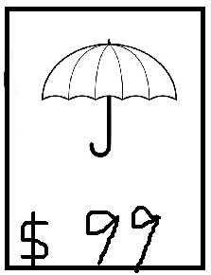  
  ( ) | ( ) | ( )
  ( ) | ( ) | ( )
  ( ) | ( ) | ( )
  To: Tina (TinaEgypt@gmail.com)
  Subject: The Pink Tent Is on Sale!
  Hi Tina,
  I want to buy a new tent. There is a big sale at AH online store. The pink tent is NT$644. It’s on sale! Do you want to buy it, too? What do you do in your free time ? We can go camping together. Hope to hear from you soon.
  Best wishes,
  Lily *tent 帳篷
   Lily (LilyTW@gmail.com)
  Dear Lily,
  I want to buy a pink tent, too. Please help me order it. I usually go camping or hiking in my free time. We can go camping together for sure. See you soon!
  Cheers,
  Tina *order 下單
  1. ______ __________________ | 4. ________________
  2. ______ __________________ | 5. ________________
  3. ______ __________________ | 6. ________________
  (依照文法做動詞變化) go do fish surf swim
  scarf sweater pants
桃園市桃園區建德國小110學年度第二學期六年級英語領域 期中定期評量聽力稿
命題範圍：康軒Follow Me Unit 1&2、Review 1
A. Listen and Mark仔細聽，選出聽到的字：(共5分)

1. boy 2. oil 3. house 4. loan 5. cloud

B. Listen and Number仔細聽，寫上代號A、B、C：(共9分)

1. A. shirt B. socks C. shorts

2. A. sweater B. sneakers C. scarf

3. A. go hiking B. go surfing C. go biking

C. Listen and Number 仔細聽，選出適當的答案 (共8分)

1. What do you do in your free time?
2. Oh, These are your bike, helmet and water bottles. Do you go biking?
3. Oh my god, look at the price. These sneakers are seven thousand and ninety
dollars! How much are these sneakers?
4. We are watching the basketball game now. Our school is winning, 55-40. Nice shot!

D. Listen and Fill In 先讀題目，聽Elsa和Peter的對話作答(共12分)

Peter: Let’s go shopping!
Elsa: Sure. I love shopping! What do you want to buy?
Peter: I want two pairs of pants. How about you?
Elsa: It’s so cold in winter. I want to buy a blue sweater.
Peter: See, that blue sweater is pretty cute!
Elsa: Wow, nice! How much is that sweater?
Peter: It’s eight hundred and thirty dollars.
Elsa: Eight hundred and thirty dollars? Great! Let’s buy them all!

