桃園市桃園區建德國小110學年度第二學期四年級 英語領域 期中評量試卷
班級：______ 中文姓名：___________ 座號：______ 家長簽章：______
一、Listen and Check仔細聽，將聽到字的打V(每格2分，共18分)
1. | □ kite | □ kit | 2. | □meet | □met | 3. | □ vane | □ van
4. | □ fate | □ fat | 5. | □ hide | □ hid | 6. | □ beet | □ bet
7. | □ teen | □ ten | 8. | □ mape | □ map | 9. | □ pine | □ pin
二、Listen, Number and Write 仔細聽，用阿拉伯數字寫出正確的時間(每題2分，共10分)
例.  10 ：15 | 1.  ： | 2.  ：
3.  ： | 4.  ： | 5.  ：
三、Listen and Number 仔細聽，並填入正確的順序(1~4) (每題2分，共8分)
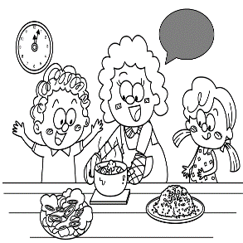 | 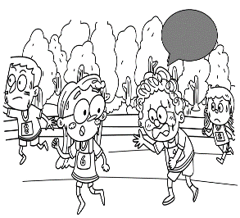 |  | 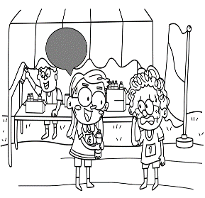
四、Listen and Check 仔細聽，勾選正確的圖片(每題2分，共8分)
1. |   □ | 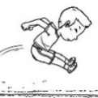  □ | 2. |   □ |   □
3. |   □ | 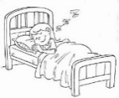  □ | 4. | 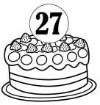  □ |   □
五、Listen and Choose仔細聽，選出正確的答案(每題2分，共8分)

1. ( ) It’s _____.  ① three thirty-five  ② three fifty-five  ③ three twenty-five | 2. ( ) I’m _____.  ① eating ② writing  ③ cooking
3. ( ) It’s _____.  ① seven ten ② six ten  ③ eleven ten | 4. ( ) _____ she doing?  ① What ② Whats  ③ What’s
六、Look and Write看圖，並用英文寫出正確的時間(每題3分，共9分)
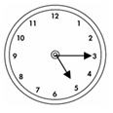  1. | 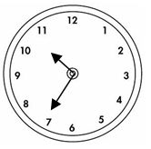  2. | 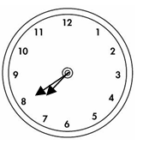  3.
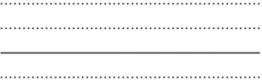
七、Look and Write看圖，並根據提示完成句子(每題3分，共18分)
1. |  | He can . | 2. |  | He is .
3. |  | I can . | 4. |  | She is .
5. |  | I am . | 6. | 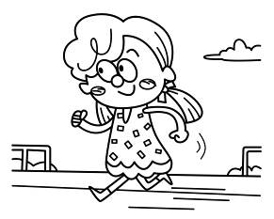 | She is .
八、Read and Write，請將數字由小到大排列(每題3分，共9分)
例.A.two | B.one | C.three |  | ( B ) | ( A ) | ( C )
1.A.nineteen | B.thirteen | C.sixteen |  | ( ) | ( ) | ( )
2.A.twenty | B.twelve | C.two |  | ( ) | ( ) | ( )
3.A.forty | B.fifty | C.thirty |  | ( ) | ( ) | ( )
九、Read and Mark O or X根據短文或對話，將相符的敘述畫O，不符的敘述畫X
(每題2分，共12分)
- Amy: What are you doing?  Kevin: I’m cooking.  Are you hungry?  Amy: Yes, I am.  Kevin: What do you want?  Amy: I want a hamburger.  Kevin: Me, too.  ① ( ) Kevin is eating.  ② ( ) Amy is hungry.  ③ ( ) Amy and Kevin want  hamburgers. | - Adam: Be quiet, please.  Una: What time is it?  Adam: It’s one forty-five.  My brother is sleeping.  Una: I’m sorry.  Adam:That’s OK.  Una: How old is your brother?  Adam: He’s eight years old.  - ( ) It’s 1:45.  - ( ) Adam is sleeping.  - ( ) Adam’s brother is  nine years old.

