桃園市建德國小105學年度第2學期五年級英文領域 期末定期評量試卷
五年____班 座號：_____ 姓名：____________ 分數：__________

- Listen and choose (10%) 聽並選出正確的單字
  - ( ) a. pay b. play c. pray
  - ( ) a. glad b. grad c.great
  - ( ) a. proud b.ground c. brush
  - ( ) a. class b. glass c. grass
  - ( ) a. ply b. pry c. dry

- Listen and check (24%) 聽並在對應的圖片寫下號碼，拼寫出單字。
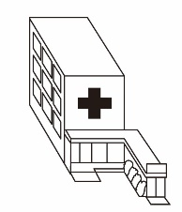


( ) ( )
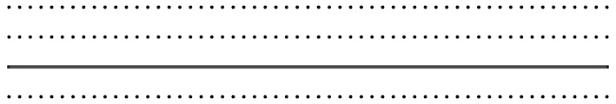

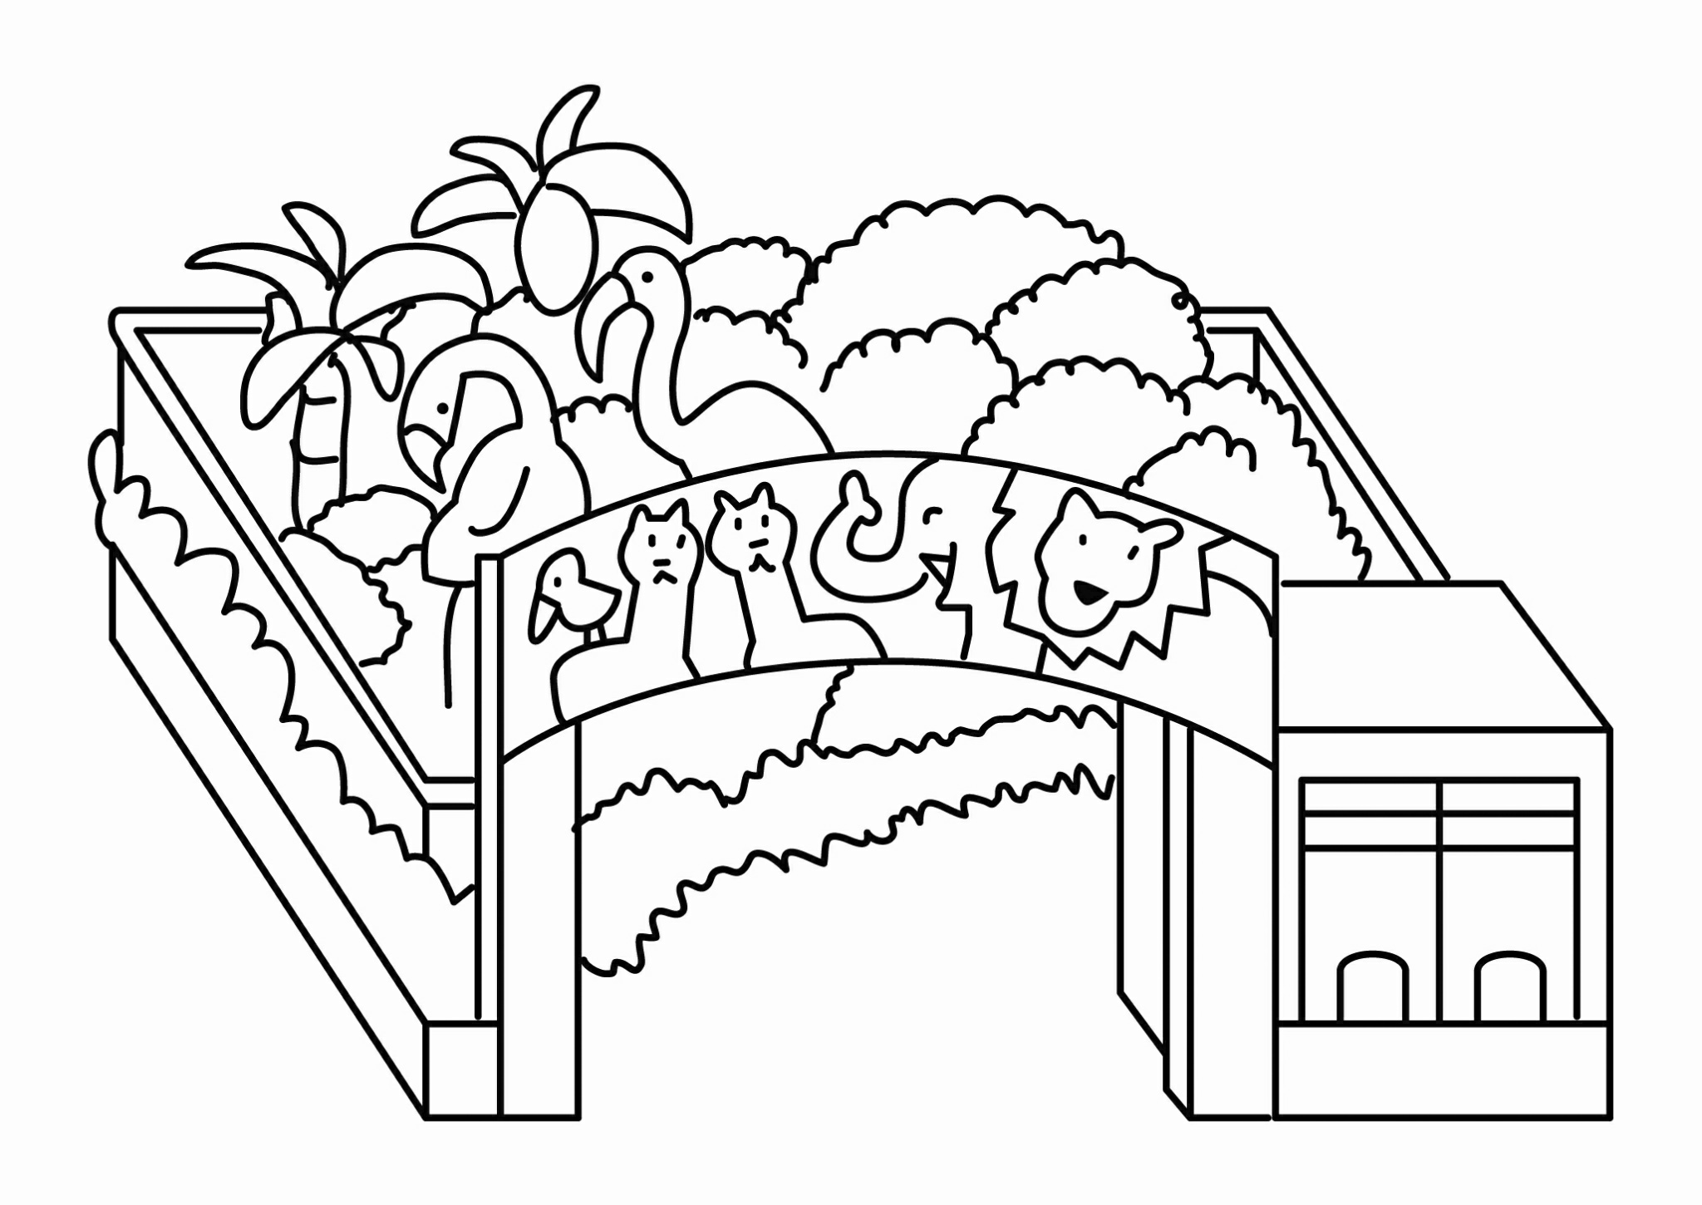
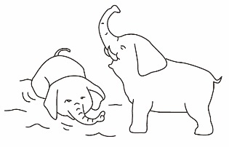

( ) ( )

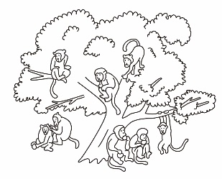
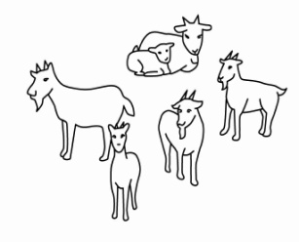

( ) ( )

三、Listen and choose (10%) 聽並選出正確的回應句
1. ( ) a. Let’s try some.
b. I’m sorry.
c. OK.
2. ( ) a. He’s at home.
b. Let’s take a rest.
c. It’s on White Street.
3. ( ) a. Hold on tight.
b. My pleasure.
c. Be quiet.
4. ( ) a. I’m going to the restaurant.
b. I’m in the restaurant.
c. I don’t see the restaurant.
5. ( ) a. They are ten tigers.
b. There are ten lions.
c. They are ten lions.

四、Listen and number (8%) 聽並標上號碼
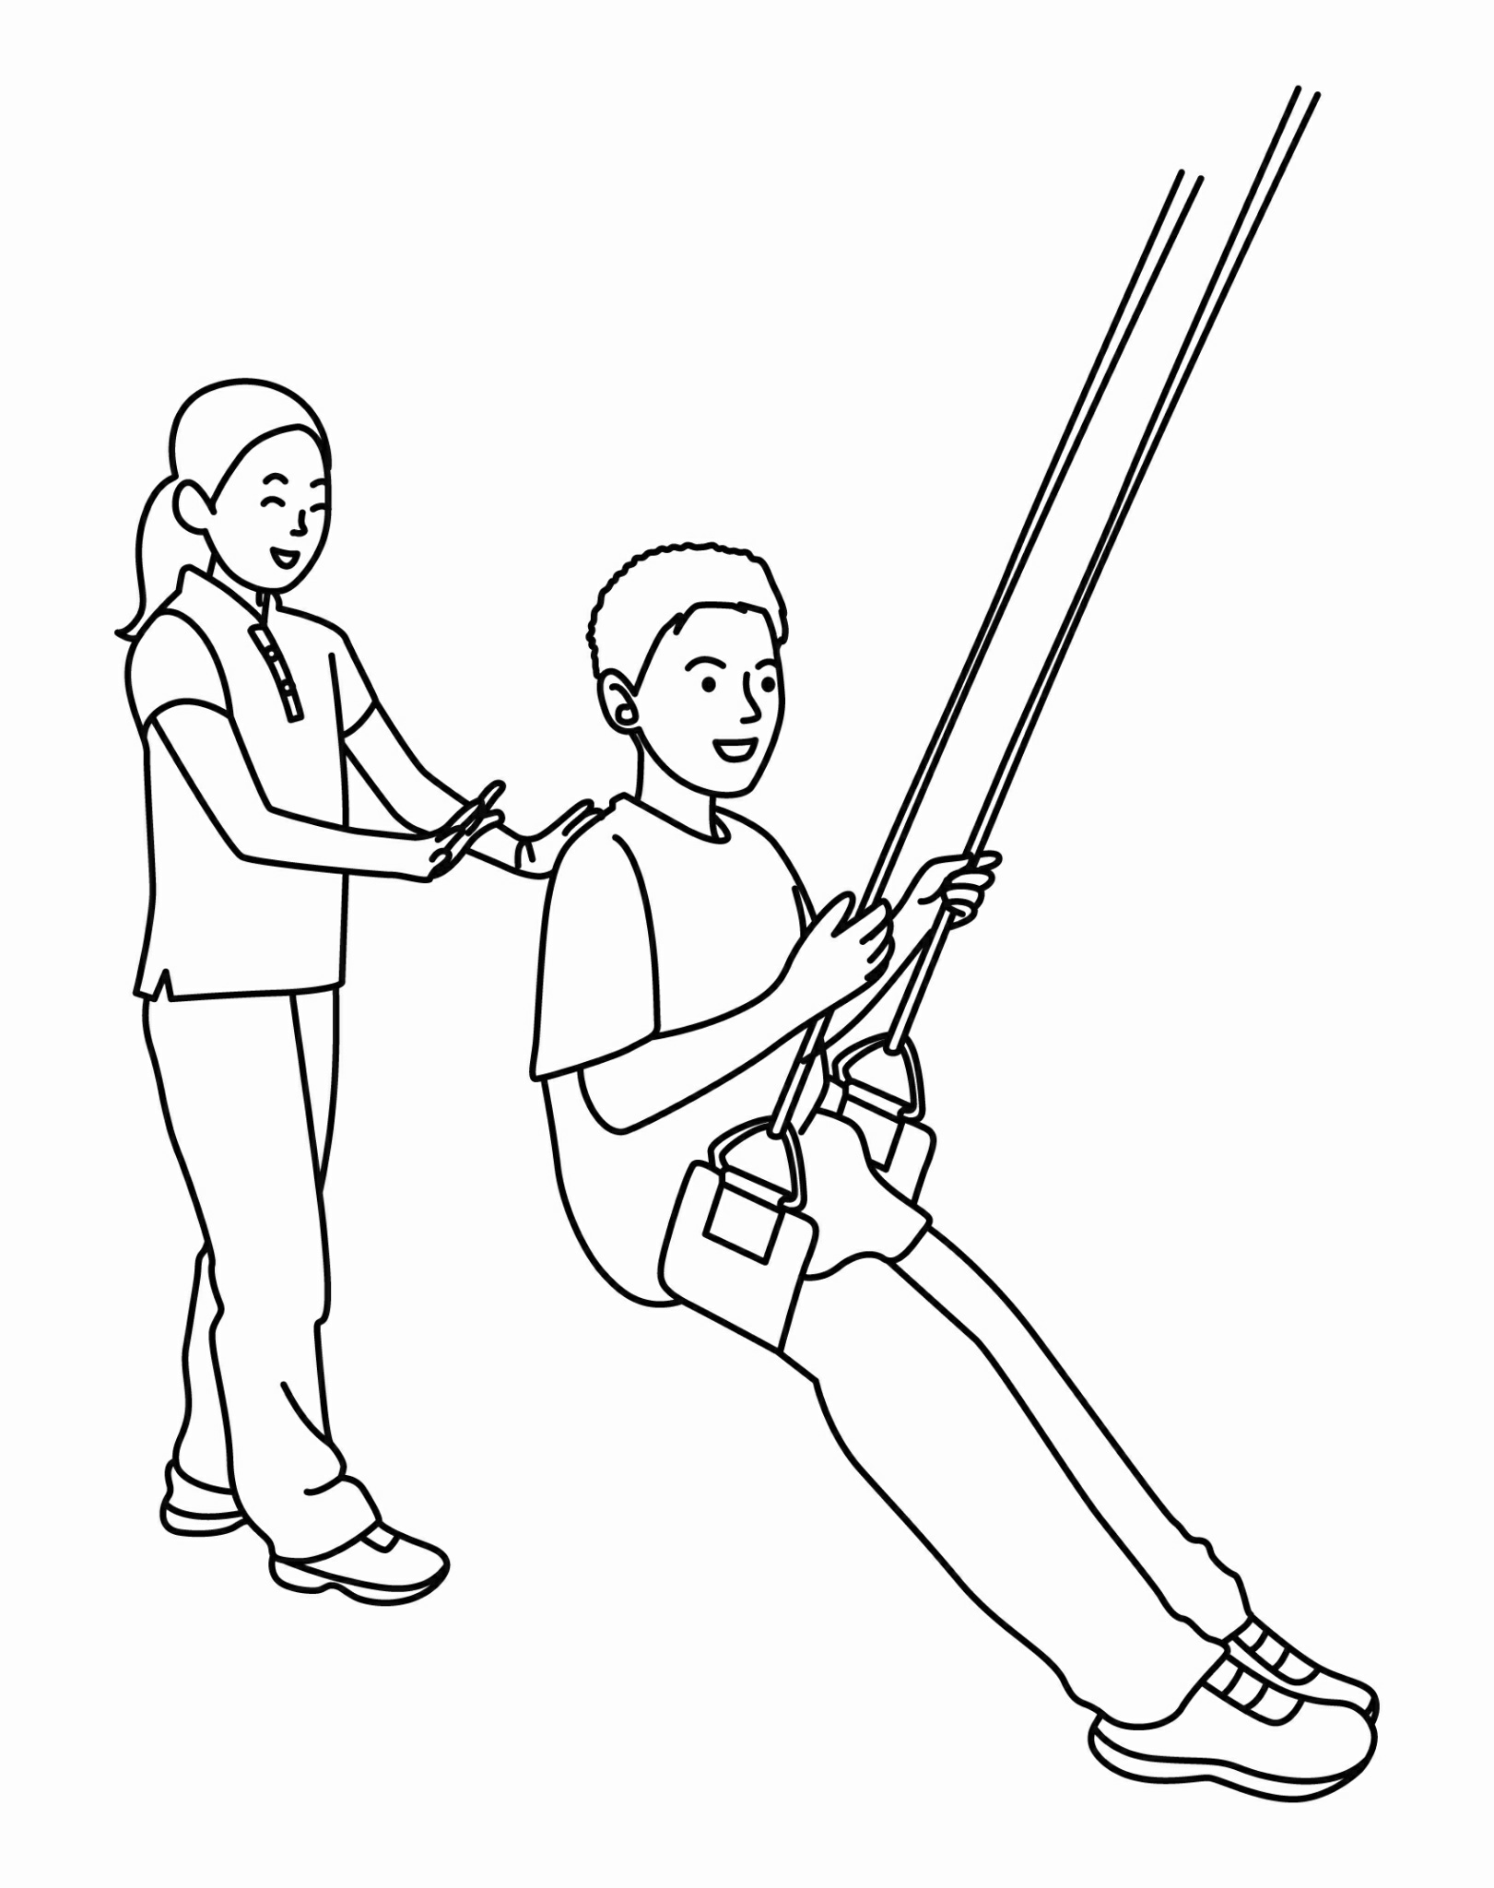
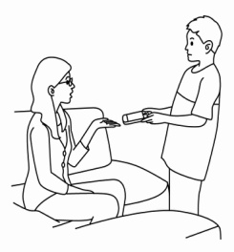

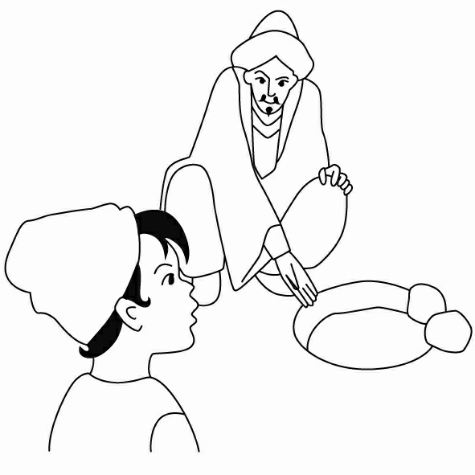
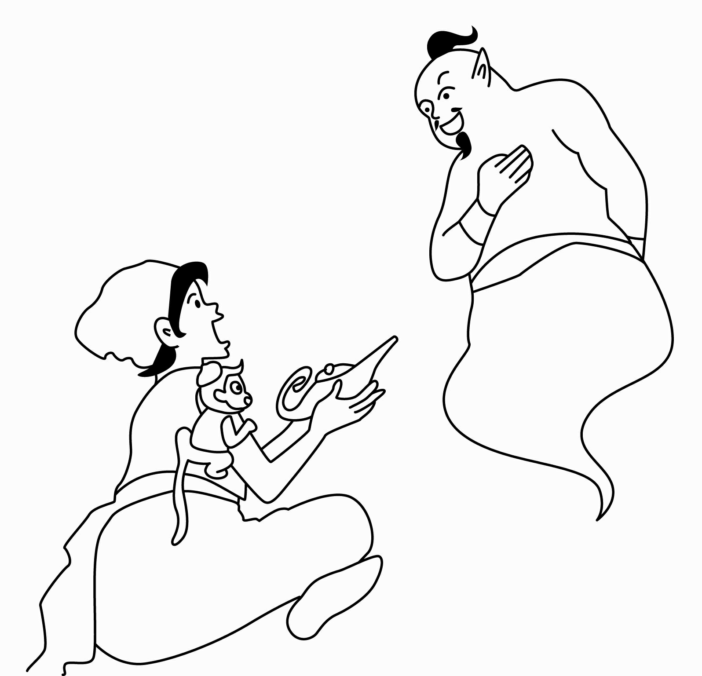

五、Look and Write (20%)看圖，依提示完成句子

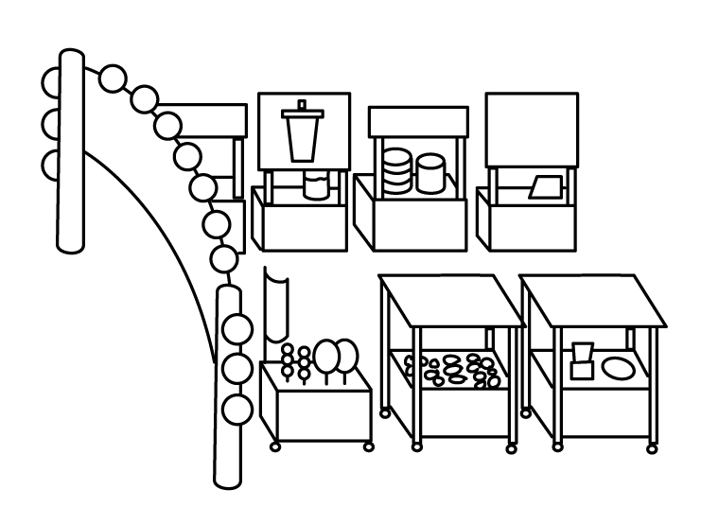

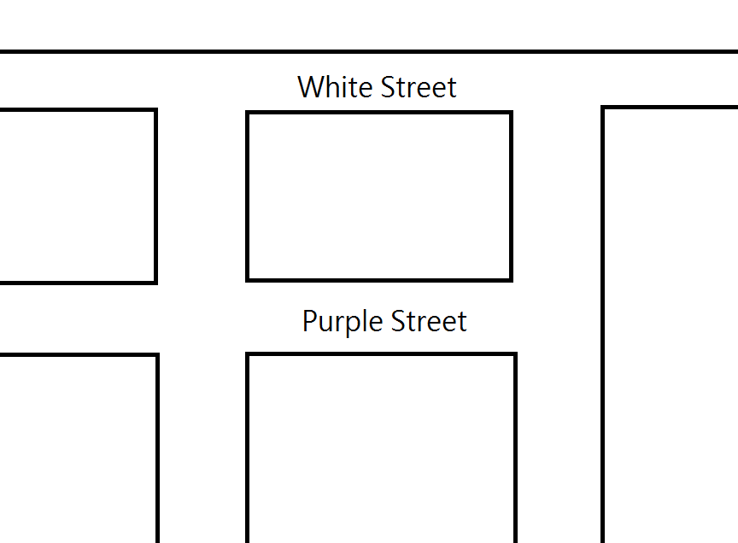

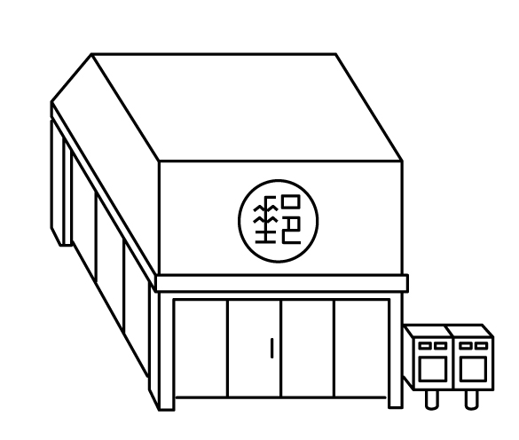
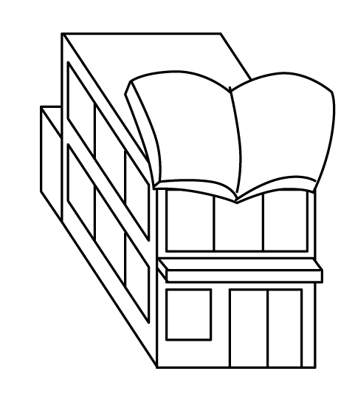
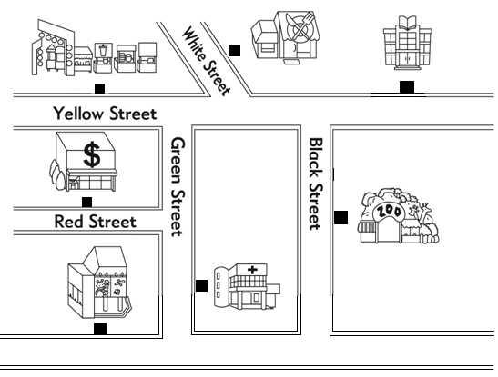
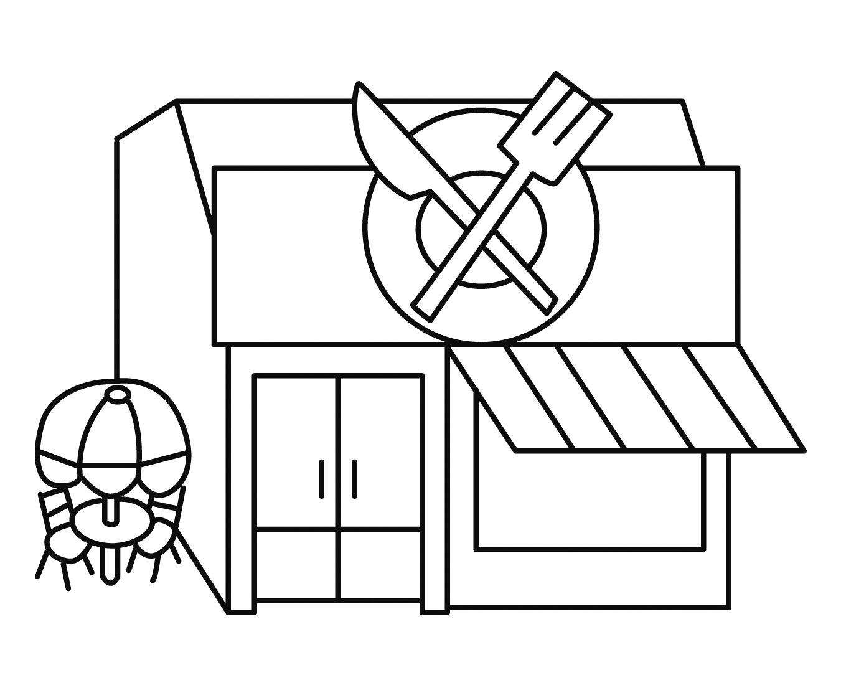
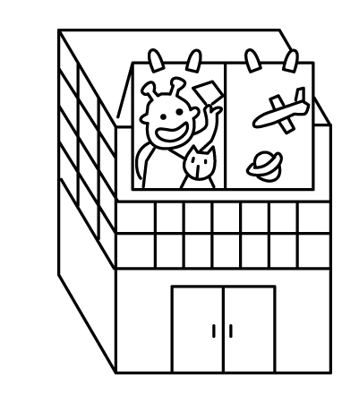

1. The ______________________ is on Purple Street.
2. The ______________________ is on Black Street.
3. The ______________________ is on Green Street.
4. Where ________________ you going?
I’m going to the _______________________________.
5. Where are ________________ going?
They are going to the ________________________.
Happy Zoo

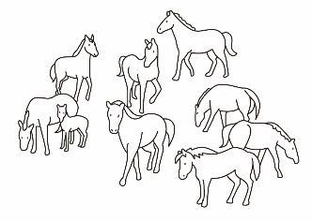
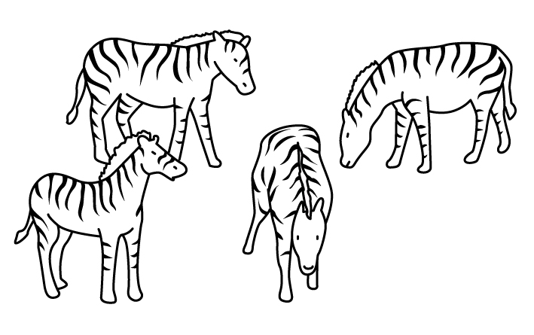
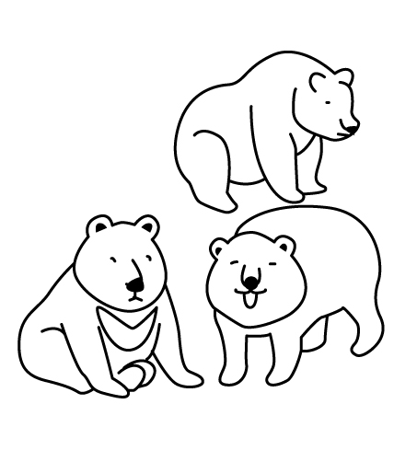


1. I see nine ________________.
2. I see four ________________.
3. How many bears are there?
There are _____________ bears.
六、Read and choose (10%) 仔細讀，選出正確的答 案
( ) 1. A: ______ are you going?
B: We’re going to the supermarket.
(a) What (b) How (c) Where
( ) 2. Where ____ Aladdin going?
(a) does (b) are (c) is
( ) 3. The bank is _____ Jane-Der Street.
(a) on (b) in (c) under
( ) 4. What ____ you see?
I see a big hippo in front of me.
(a) does (b) do (c) is
( )5. A: How many _______ are there?
B: There _____ one tiger.
(a) tigers ;is
(b) tigers ; are
(c) tiger ; are

七、Unscramble (18%) 重組句子
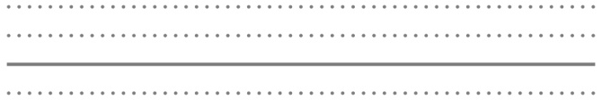
  - is∕zoo∕the∕Where
?

  - bank∕He’s∕going ∕the ∕to
.

Remember To Check !

