桃園市桃園區建德國小105學年度第1學期五年級英文領域 期末定期評量試卷
五年____班 座號：_____ 姓名：__________ 家長簽名：__________

- Listen and Circle (10%)
聽並圈出聽到的單字。
  - bit bite but
  - rod rid ride
  - feed fed find
  - hot hop hope
  - dot date dig

- Listen, Number and Write. (24%)
聽並在對應的圖片寫下號碼，拼寫出單字。
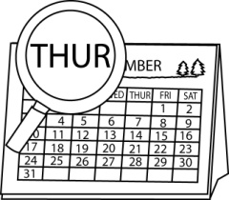
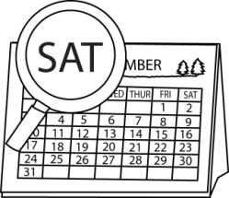

( ) ( )
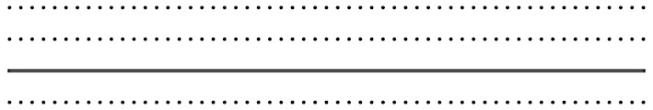


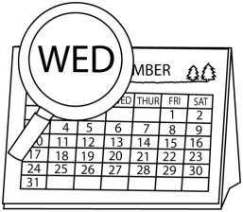

( ) ( )




( ) ( )

- Listen and Choose. (8%)
聽並選出正確的答案。
  - ( ) (A) My sister is not crying.
(B) My mother is singing.
(C) My brother is talking.
  - ( ) (A) No, it isn’t. It’s Thursday.
(B) No, it’s today.
(C) Yes, it is. It’s Friday.
  - ( ) (A) I don’t know.
(B) Let’s take a look.
(C) Thank you.
  - ( ) (A) Here you are.
(B) Yes, I’m!
(C) Me, too.
- Listen and Number (8%)
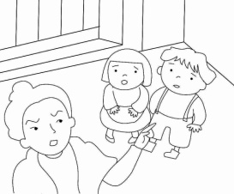
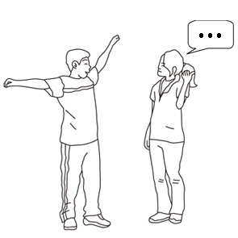
仔細聽，並標上號碼。

( ) ( )
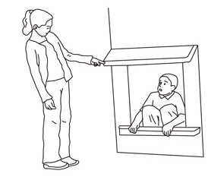
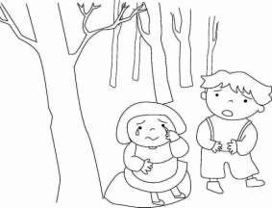

( ) ( )

- Read and Choose
讀一讀，選出正確的答案 (10%)
( ) 1. Tuesday.
(A) It’s (B) It (C) Is
( ) 2. The girl is sad. She is .
(A) cry (B) cries (C) crying
( ) 3. We don’t go to school on .
(A) Monday
(B) Sunday
(C) Friday
( ) 4. A：Who’s crying?
B：__________________
(A) A man is crying.
(B) My brother is laughing.
(C) A boy is not crying.
( ) 5. A: Follow me, please.
B: _________
(A) I’m sorry.
(B) Yes, I am.
(C) OK.

- Look and write (10%)
依據圖片，填入正確的答案。
1.

I _____ talking.
Tom ______ talking.
She is ________________.

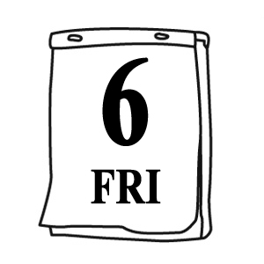

2.

Q：What ________ is today?
A：Today is _________________.

七、 Read and Write. (16%)回答問題。
- What day is today? (根據考試當天)
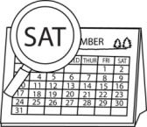
___________________________________________________
- Is today Sunday?

___________________________________________________
- Who’s talking?
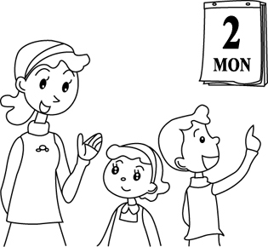
___________________________________________________
- What day is today?

____________________________________________________

- Unscramble 重組句子(14%)
  - Tuesday ∕Is ∕ today ∕?
_______________________________________________
  - A / cooking / woman / . / is
_______________________________________________
  - brother / shouting / . / is / My
_______________________________________________

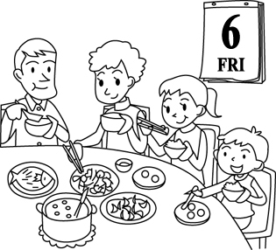
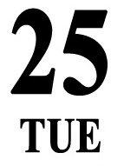
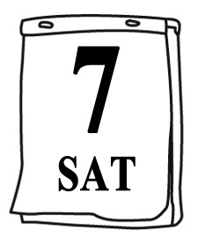
Remember To Check!

