桃園市桃園區建德國小105學年度第1學期四年級英語領域期末定期評量試卷
四年 ___班 座號：___ 姓名：__________ 分數：__________

- Listen and Check 仔細聽，將聽到的發音字打勾(18％)
1.( ) save  ( ) safe | 2.( ) zoom  ( ) soon | 3.( ) fine ( ) vine
4.( ) zip  ( ) sip | 5.( ) fat ( ) vat | 6.( ) sing  ( ) zing
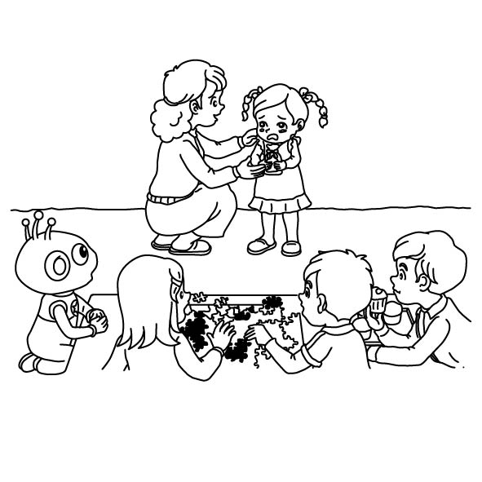
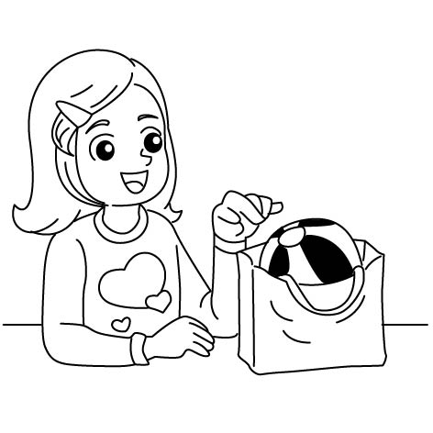
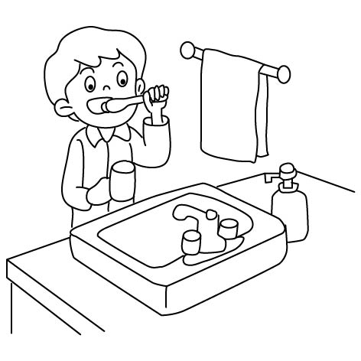
- Listen and Number 仔細聽，按照聽到的順序寫上號碼1-6 (12％)

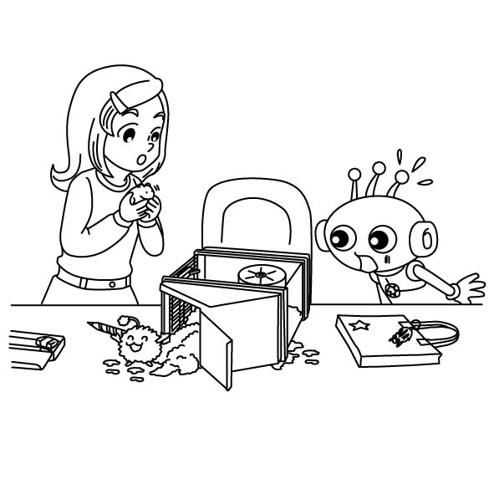
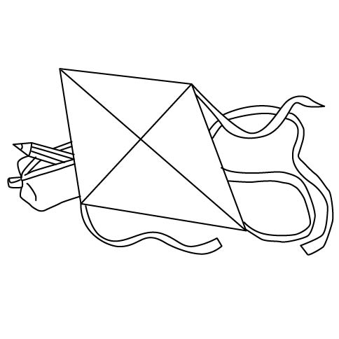
( ) ( ) ( )
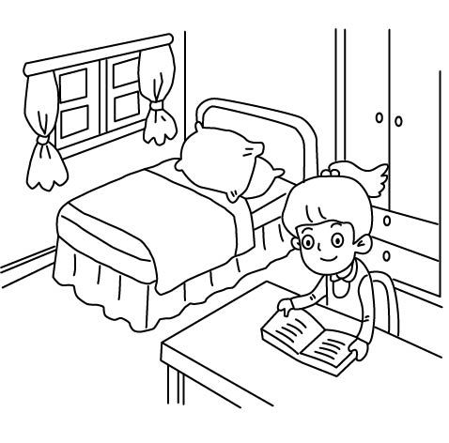
( ) ( ) ( )
- Listen and Mark 仔細聽，句子與圖片相符畫O，不符畫X (8％)
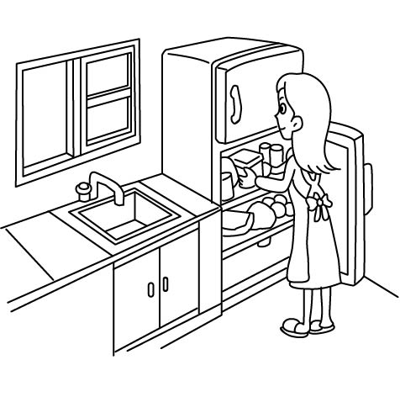
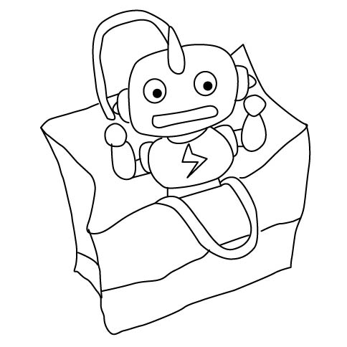
- 2.
( ) ( )
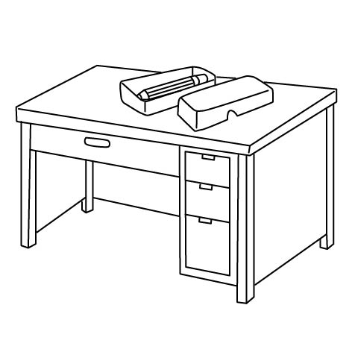
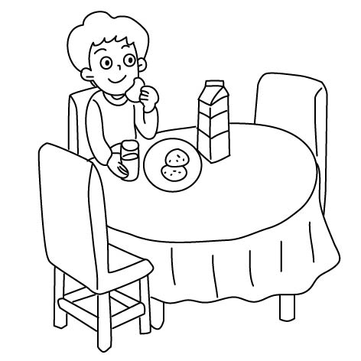
3. 4.
( ) ( )
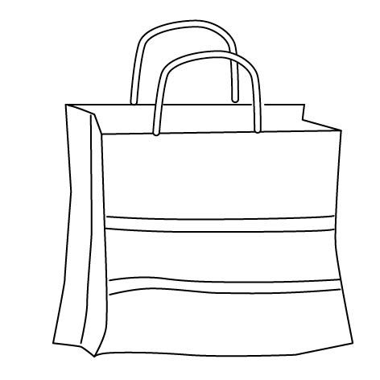
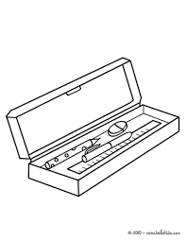
- Listen, Number, and Write 仔細聽，按照聽到的順序先將圖片標上號碼，再寫出正確的單字(15％)
( ) ( )
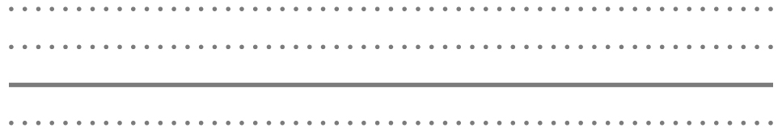
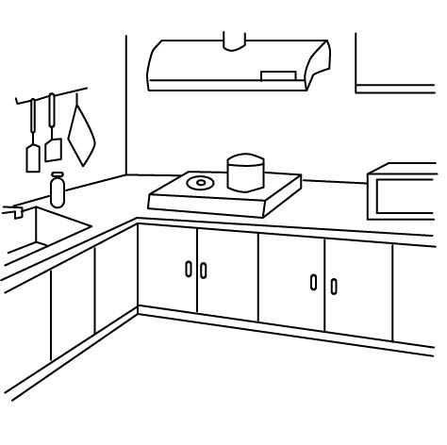
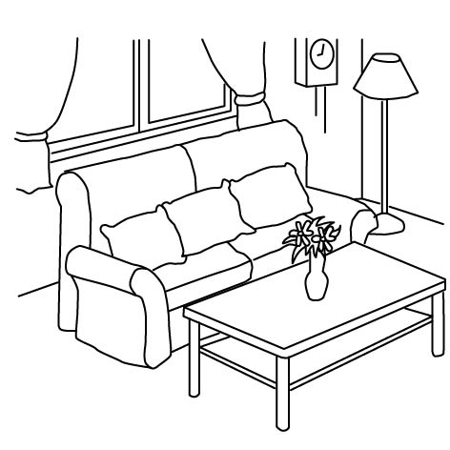
( ) ( )
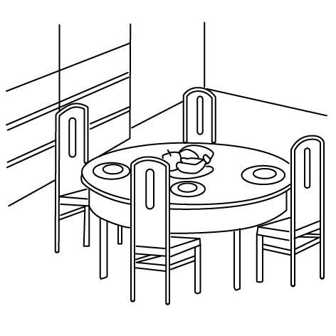
( )
- Look and Choose 看圖選出正確的句子 (15％)
1. ( ) | A: Where’s Grandpa?  B: ＿＿＿＿＿＿  (A) He’s in the living room.  (B) She’s in the bathroom.  (C) He’s in the dining room.
2. ( ) | A: Where’s my yo-yo?  B: ＿＿＿＿＿＿  (A) It’s in the bag.  (B) It’s on the chair.  (C) It’s under the box.
3. ( ) | (A) My cat is on the bag.  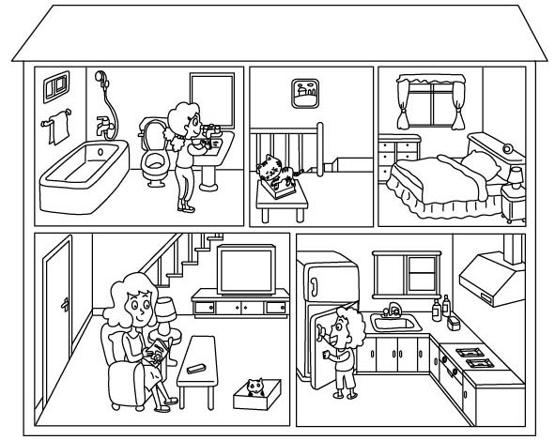  (B) My dog is on the box.  (C) My cat is in the bag.
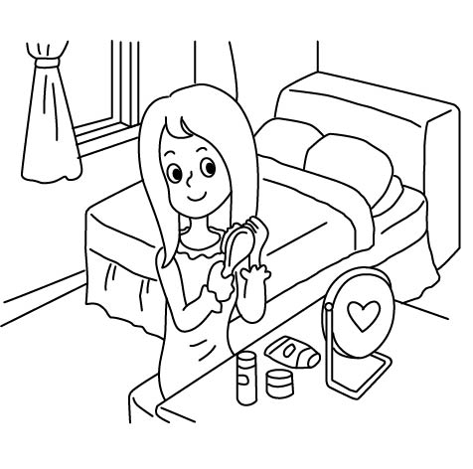  4. ( ) | A: Where are you?  B: ＿＿＿＿＿＿  (A) She’s in the bedroom.  (B) I’m in the bedroom.  (C) She’s in the bathroom.
5. ( ) | A: ＿＿＿＿＿＿  B: It’s on the box.  (A) What’s your ball ?  (B) Where’s your ball ?  (C) Who’s your ball ?
- Look,Read and Write 請依據圖示填入” in” ,”on”,”under ”(12％)
- Look,Read and Copy請依據圖示寫出正確的答案( 20％ )
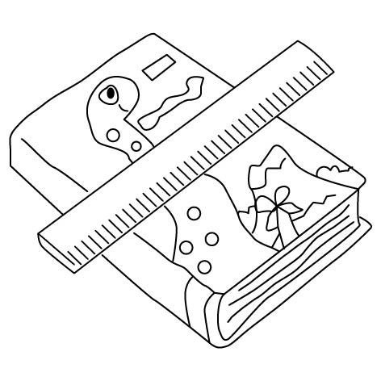 | The book is the ruler.
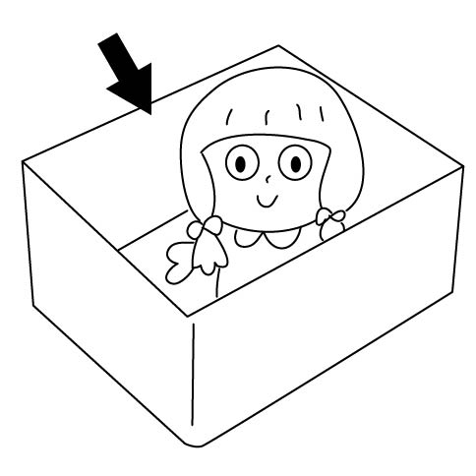  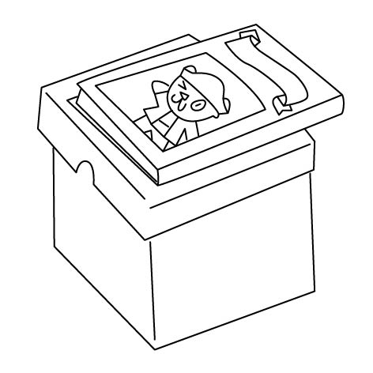 | The doll is the box.
 | The book is the box.
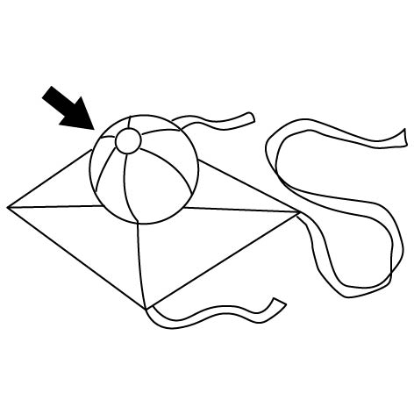  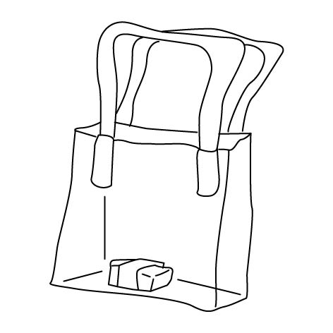 | The ball is the kite.
 | The eraser is the bag.
 | The pencil case is the kite.

Amy

Ken

bathroom Where She book on
Ken living room It’s She’s in
- Where’s Amy ?
is in the .
- Where’s the cat ?
It’s the .
- Where’s Mom ?
in the .
- Where’s the hamster ?
the box.
- is ?
He’s in the kitchen.

