桃園市桃園區建德國小109學年度第1學期五年級英語領域期中定期評量試卷
Class：________ Number：________ Name：________________________
A Listen and Check (10％)
仔細聽，將聽到的字打勾
1. | ( ) | sell | ( ) | shell
2. | ( ) | phone | ( ) | hone
3. | ( ) | hen | ( ) | when
4. | ( ) | watch | ( ) | wash
5. | ( ) | fin | ( ) | thin

B Listen, Number and Write (24％)
仔細聽，依序寫上編號，再寫出單字
□ | 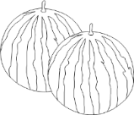 | □ | 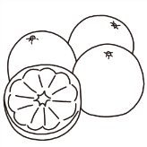
____________________________ |  | ____________________________
□ |  | □ | 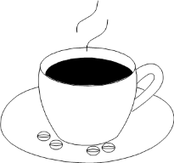
____________________________ |  | ____________________________
□ | 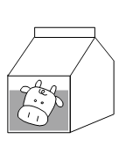 | □ | 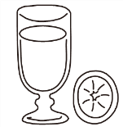
____________________________ |  | ____________________________
□ | 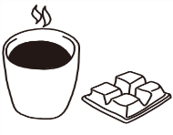 | □ | 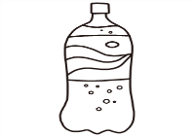
____________________________ |  | ____________________________
C Listen and Choose (15％)
仔細聽，選出適當答句
( ) 1. (A) I want a hamburger.
(B) I want some tea.
(C) I want some ice cream.
( ) 2. (A) Yes, I am.
(B) Yes, we are.
(C) No, I don’t.
( ) 3. (A) Yes, we do.
(B) No, I don’t. I like apples.
(C) Yes, I am.
( ) 4. (A) He wants some lemonade.
(B) She wants some water.
(C) I want some tea.
( ) 5. (A) Yes, he likes papayas.
(B) No, I don’t like pears.
(C) No, he likes papayas.
D Read and Choose (12％)
仔細讀，選出正確的答案
( ) 1. A:Amy, what do you want to
drink?
B: ______________
(A) I want some lemonade.
(B) She wants some water.
(C) We want some tea.
( ) 2. (A) Max doesn’t like bananas. He
likes apples.
(B) Max doesn’t like pears. He
likes bananas.
(C) Max doesn’t like bananas or
apples.
( ) 3. A:Do Wendy and Bob like apples?
B: _____________ They like pears.
- Yes, they do.
(B) No, we don’t.
(C) No, they don’t.
( ) 4. A:What _________ your mom and dad
want to _________?
B:They want some tea.
(A) do, drink
(B) do, eat
(C) does, drink
( ) 5. A:What does Cindy want to drink?
B: _______________
(A) No, she doesn’t.
(B) She wants a hamburger.
(C) She wants some water.
( ) 6. I like Betty. She is the __________ of
my eye.
(A) apples
(B) apple
(C) grape
E Read and Answer依提示完成句子(20％)
※注意大小寫、動詞變化，單字可重複使用
 | Fruits |  | Drinks
Joe | ♥ |  |  | ♥
David |  | ♥ | ♥
Ivy | ♥ |  | ♥
Nancy |  | ♥ |  | ♥

do does don’t doesn’t
like want yes no
- _______________ Joe like bananas?
_______________, he _______________.
- _____________ David and Nancy like apples?
_______________, they _______________.
- What _______________ Ivy want to drink?
She _______________ some tea.
- David _______________ want bananas and
water.
He _______________ apples and tea.

F Read and Mark (9％)
仔細讀，符合文意的句子畫 O，錯的畫 X
Jane:Tim, I want to make some tea. Do you
want some?
Tim:No, thanks. I don’t drink tea.
Jane:How about coffee?
Tim:OK. It’s my cup of tea.
Jane:Good. I can make some for you.
( ) 1.Tim wants to make tea.
( ) 2.Tim wants some tea.
( ) 3.Tim wants some coffee.

G Read and Write (10％)
根據事實，回答問題
- Do you like bananas?
_________________________________________________________

- What do you want to drink?
_________________________________________________________

